Tiniroto School
Annual Implementation Plan
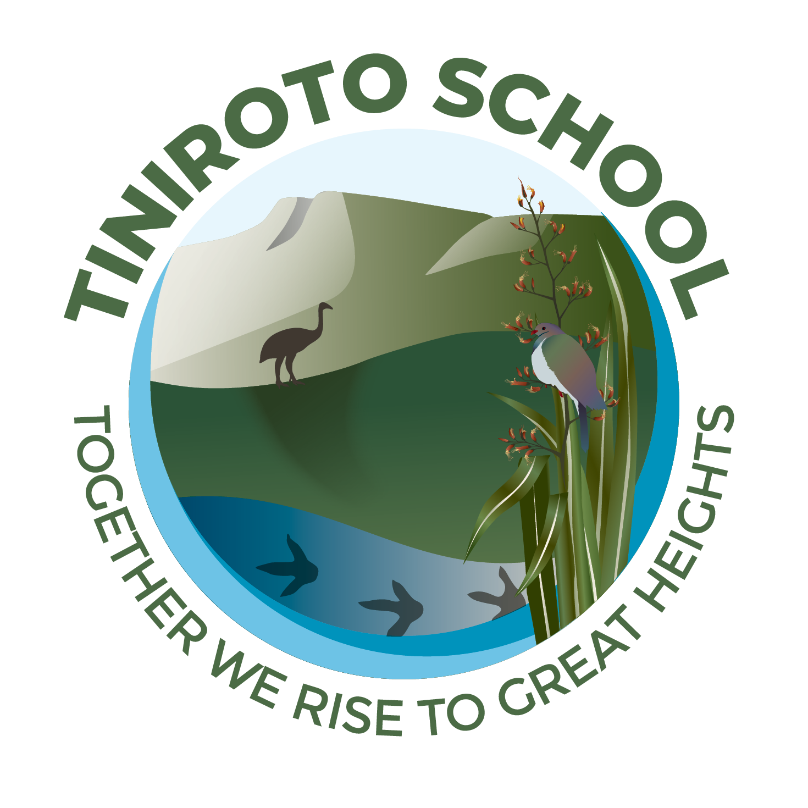
2026

Tiniroto School | 06 863 7129| 14 School Road, Tiniroto
Tiniroto School Annual Implementation Plan - 2026
Mission: Together We Rise To Great Heights

Vision: Confident children with strong values prepared for future success

Values: Respect, Integrity, Self Management and Empathy
The school entered 2026 with significant leadership and staffing changes, including the appointment of a beginning principal in Term One. Following a period of considerable disruption over the past year, a newly formed board, refreshed administration, and new staff are now in place. Together, we are focused on establishing stability, strengthening systems and relationships, and determining a clear, cohesive direction for the school’s future.
Our Annual Implementation Plan will give effect to Te Tiriti o Waitangi by building shared understanding among our school community of its significance and our obligations as a school. We will strengthen awareness of whakapapa and the importance of connection, ensuring these principles are reflected in our relationships, teaching, and decision-making. Through this, we aim to foster a culturally responsive environment where all learners feel a strong sense of belonging and identity.
Key priorities  - Align school planning and delivery to The New Zealand Curriculum and assessment requirements.  - Embed structured literacy and mathematics approaches schoolwide.  - Develop an attendance plan to improve regular rates.  - Embed systems to analyse achievement data to inform reading, writing and mathematics teaching across the school.  - Strengthen the school’s review and evaluation processes at all levels, with a focus on addressing specific learning needs for equitable outcomes. |  |  | Expected Outcomes  - Greater progress and achievement for all learners and equitable outcomes.  - High quality, evidence-based teaching in literacy and mathematics.  - Teaching practice aligned with curriculum and assessment requirements.  - Higher levels of regular student attendance.
Strategic Goal One - Curriculum and Assessment Coherence
Strategic Goal Two - Student Engagement and Attendance
Strategic Goal Three - Strengthen the school’s review and evaluation processes at all levels.

Strategic Goal One - Curriculum and Assessment Coherence
Annual Aim 2026 - Build and embed a coherent, school-wide curriculum that reflects our community’s context, aligns with Te Mātaiaho | The Refreshed New Zealand Curriculum, and is strengthened through effective and purposeful assessment practices.
Expected Outcome: By the end of 2026, the school will have a coherent and well-embedded curriculum that aligns with Te Mātaiaho | The Refreshed New Zealand Curriculum, demonstrating clear and purposeful connections between teaching, learning, and assessment. Teachers will implement a consistent approach to assessment, supported by shared tools and schedules that enable effective monitoring of student progress over time. Evidence will indicate strengthened teacher capability and confidence in using assessment information to inform planning, improve learner outcomes, and report progress clearly and accurately to students, whānau, and the wider school community.
How will we achieve or make progress towards the strategic goal?
- Review and map current programmes against the refreshed NZ Curriculum/Te Mātaiaho, identifying gaps and next steps in each learning area.
- Confirm and implement a schoolwide assessment schedule and tool set that aligns with curriculum priorities and supports progress tracking over time.
- Build teacher capability to use assessment information to plan, differentiate, and report learning in ways that are clear to students and whānau.
How will success be measured?
Progress toward this annual aim will be evaluated through an ongoing cycle of collaborative inquiry, reflection, and evidence gathering. Termly reviews will monitor how effectively teaching and learning align with Te Mātaiaho and support student progress through consistent assessment practices. Teachers will analyse assessment data and moderation outcomes to identify shifts in practice and student achievement, while student voice and whānau feedback will provide insights into the clarity and impact of learning. Findings from these reviews will inform next steps for professional learning, curriculum development, and future planning, ensuring that improvements are both sustainable and responsive to the needs of all learners.
Objective | Responsibility & Timeframe | Resourcing | Progress Actions | Measures | Expected Outcomes
1.1 Review and map current programmes to Te Mātaiaho, identifying gaps and actions for coherent curriculum alignment.​ | Ali/Diana  Termly | Free PLD on new curriculum | Review and map current programmes against the refreshed NZ Curriculum/Te Mātaiaho, identifying gaps and next steps in each learning area. | 1.Termly Planning  2.Termly review reports showing gap closure (e.g., new units developed).  3. Teacher confidence in using aligned assessments | By the end of 2026, teachers confidently deliver an integrated curriculum with Te Mātaiaho links, consistent assessments.
1.2 To ensure assessment practices across the school are consistent, purposeful, and aligned with the refreshed New Zealand Curriculum/Te Mātaiaho, supporting improved understanding and use of progress data to inform teaching and learning. | Ali/Diana  Termly | Free PLD on new/current assessment tools, SMART, PATs, e-AsTTle | Confirm and implement a coherent, schoolwide assessment schedule and tool set that aligns with curriculum priorities and supports progress tracking over time. | 1. Consistent use of assessment tools.  2. Staff tracking student progress over time accurately.  3. Data readily available to inform teaching. | By the end of 2026, teachers will confidently and consistently use assessment information to plan responsive learning programmes and report progress clearly to students and whānau. Shared assessment tools, moderation practices, and a schoolwide assessment schedule will support coherent teaching and learning pathways across the New Zealand Curriculum |Te Mātaiaho.
1.3 Develop consistent, confident teacher practice in using assessment evidence to inform teaching, monitor progress, and communicate learning effectively, ensuring alignment with the New Zealand curriculum| Te Mātaiaho. | Ali/Diana  Termly  Travel to hui $250 per term | Attend PLD opportunities with mentor, cluster, COP, and PLG | Attend PLD opportunities with mentor, cluster, Community of Practice (COP), and Professional Learning Groups (PLG). Ensuring alignment with the New Zealand curriculum| Te Mātaiaho. | 1.Teacher practice and confidence:  Evidence from observations, inquiry reflections, and appraisal discussions shows growing teacher confidence and consistency in analysing assessment information and adapting teaching accordingly.  2.Assessment–planning alignment:  Curriculum planning and assessment records demonstrate clear links between assessment information, learning intentions, and differentiated classroom programmes.  3.Clarity and communication of progress:  Student and whānau feedback indicates increased understanding of learning progress and next steps through clearer reporting and learning conversations. | By the end of 2026, teachers will confidently and consistently use assessment information to plan responsive learning programmes and report progress clearly to students and whānau. Shared assessment tools, moderation practices, and a schoolwide assessment schedule will support coherent teaching and learning pathways across the New Zealand Curriculum |Te Mātaiaho.
1.4 Embed structured literacy and mathematics approaches schoolwide. | Ali/Diana  Weekly/ongoing  Travel to hui $250 per term  Teacher Release | Attend PLD on structured literacy and mathematics | Provide ongoing professional learning, coaching, and collaborative planning to support consistent implementation of structured literacy and mathematics approaches across all year levels. | 1. Classroom observations, teacher planning, assessment data, and evidence of consistent use of agreed approaches across year levels. | All students experience coherent, high-quality literacy and mathematics teaching, leading to improved engagement, progress, and achievement.
Evaluative Statement- Why Did We Get These Outcomes? What Are Our Next Steps?

Strategic Goal Two - Student Engagement and Attendance
Annual Aim for (2026) Increase and sustain the proportion of students attending regularly (90% + attendance) and reduce the number of students in irregular, moderate, and chronic absence categories.
Expected Outcome: By the end of 2026, at least 80% of students will be attending school regularly (90%+ of the term), with a year‑on‑year reduction in the proportion of students in irregular, moderate, and chronic absence categories, as evidenced by termly attendance data and board reports.
How will we achieve or make progress towards the strategic goal?
- Develop and implement a whole-school attendance plan that clearly defines expectations, roles, processes, and communication with whānau.
- Use attendance data termly to identify patterns, priority groups, and to evaluate the impact of interventions; report regularly to the Board.
- Strengthen partnerships with parents, whānau, and external agencies to address barriers to attendance and support student engagement.
How will success be measured?
Success of our 2026 attendance goal will be measured through clear, data-driven indicators aligned with the annual aim of 80%+ regular attenders (90%+ attendance) and reductions in irregular, moderate, and chronic absence categories. Termly tracking and multi-stakeholder evaluation will ensure ongoing learning about effective strategies.
Objective | Responsibility & Timeframe | Resourcing | Progress Actions | Measures | Expected Outcomes
2.1 Develop and implement a whole-school attendance plan that clearly defines expectations, roles, processes, and communication with whānau to improve regular attendance and reduce non-attendance categories in line with national expectations. | Ali/Diana/BOT  Term1, ongoing | Time | Develop and Implement a whole school attendance plan that clearly defines expectations, roles, processes and communication with whanau. | 1. Proportion of students attending regularly  Measure: Percentage of students attending more than 90% of the term, reported termly.  2. Reduction in irregular, moderate, and chronic absence  Measure: Termly proportion of students in each category: irregular (80–90%), moderate (70–80%), chronic (≤70%).  3. Implementation of attendance plan processes and whānau engagement  Measure:All unexplained absences followed up on the day using agreed processes (e.g., text/phone by set time),  4. Recorded whānau contact and support actions for all students at STAR/concern thresholds (or equivalent tiered response),  5. Termly review of attendance data and actions by the leadership/board. | By the end of 2026, at least 80% of students will be attending school regularly (90%+ of the term), with a clear year‑on‑year reduction in the proportion of students in irregular, moderate, and chronic absence categories, as shown in termly attendance data and board reports. The whole‑school attendance plan will be embedded in daily practice, with clearly understood expectations, roles, and processes, and strong, responsive communication with whānau supporting improved attendance for all learners.
2.2 Use termly attendance data analysis to drive targeted interventions, achieving and sustaining 90%+ regular attendance for at least 80% of students by end of 2026 | Ali/Diana  Term1, ongoing | Time  Attendance initiatives | Use attendance data termly to identify patterns, priority groups, and to evaluate the impact of interventions; report regularly to the Board. | 1.Proportion of students with 90%+ attendance per term (target: 80%+ by year-end).  2.Year-on-year % reductions in irregular (85-89%), moderate (80-84%), and chronic (<80%) absence categories.  3. Number of priority groups (e.g., by year level, demographics) showing improved attendance post-intervention, tracked termly. | By the end of 2026, termly data and Board reports will show at least 80% of students attending regularly (90%+ per term), with consistent year-on-year drops in irregular, moderate, and chronic absence rates—directly evidencing intervention effectiveness and progress toward the Annual Aim.
2.3 Strengthen partnerships with parents, whānau, and external agencies to identify and remove barriers to regular attendance. | Ali/Diana/BOT  Ongoing | Time  Attending/holding community events | Strengthen partnerships with parents, whānau, and external agencies to address barriers to attendance and support student engagement. | 1. Percentage of unexplained absences followed up with whānau contact and intervention within 5 days.​  2. Number of partnership meetings or workshops held with whānau and external agencies per term to address attendance barriers.  3. Proportion of chronically absent students (attending 70% or less) receiving targeted support via external agency referrals.​ | By the end of 2026, at least 80% of students will attend school regularly (90%+ of the term), with a year-on-year reduction in irregular, moderate, and chronic absence categories, as evidenced by termly attendance data and board reports. This aligns with the annual aim through strengthened whānau and agency partnerships that directly tackle barriers.
Evaluative Statement- Why Did We Get These Outcomes? What Are Our Next Steps?

Strategic Goal Three - Strengthen review and evaluation processes
Annual Aim For 2026 By the end of 2026, establish and embed a cyclical review framework that engages teachers, leaders, the board, and whānau in regular evaluation to strengthen teaching, learning, and school-wide decision-making across classroom, school, and board levels.
Expected Outcome - By the end of 2026, the school will have a consistently implemented cyclical review process that leads to documented improvement actions in response to evidence from classroom, school, and board-level evaluations. These actions will contribute to improved learner outcomes, more equitable progress for Māori and diverse learners, and stronger confidence in data-informed decision-making across the school community.
How will we achieve or make progress towards the strategic goal?
- Co-construct a simple, coherent cyclical review framework that outlines key phases (inquire, gather evidence, analyse, act, evaluate) and aligns with existing planning and reporting systems across classroom, school, and board levels.
- Build staff capability in using evidence for improvement, including analysing assessment data, student voice, and culturally responsive evaluation practices, with a focus on equity for Māori and diverse learners.
- Strengthen whānau engagement by creating intentional opportunities to gather input, share findings, and respond to community perspectives, particularly Māori whānau, ensuring their voice shapes decision-making.
- Use consistent tools and templates for documenting inquiries, findings, and next steps, with regular monitoring of action impacts on learner progress, to foster accountability and data-informed confidence.
How will success be measured?
Framework Implementation: 100% of teachers, leaders, and board complete at least two full review cycles using the co-constructed framework, with all phases documented in school systems by end of 2026.
Action and Impact Tracking: All reviews result in 3-5 documented improvement actions per cycle, with 80% showing measurable progress in learner outcomes and equity gaps (e.g., via achievement data and engagement metrics) by year-end board report

Objective | Responsibility & Timeframe | Resourcing | Progress Actions | Measures | Expected Outcomes
3.1 Co-construct a simple, coherent cyclical review framework that outlines key phases (inquire, gather evidence, analyse, act, evaluate) and aligns with existing planning and reporting systems across classroom, school, and board levels. | Ali/Diana/BOT  Term1, ongoing  Term 2, May 26-29 | Time  PLD on Governance  Beginning Principals Conference 2026 and Multi Level Mathematics | Co-construct, implement, and embed a consistent cyclical review framework across the kura, aligning inquiry processes (inquire, gather evidence, analyse, act, evaluate) with classroom, syndicate, and Board planning and reporting systems. | 1. A documented, agreed cyclical review framework is in place and used across the kura.  2. 100% of teaching teams are using consistent inquiry and review processes aligned to the framework.  3. Planning, assessment, and reporting documents show clear alignment to the five inquiry phases.  4. Staff demonstrate increased clarity and confidence in using evidence to inform teaching and next steps.  5. Board reports reflect consistent, evidence-based information linked to the framework.  6. Improved consistency in tracking, analysing, and responding to learner progress, particularly for Māori and diverse learners. | By the end of 2026, the school will have a coherent cyclical review framework implemented school-wide, aligning classroom, leadership, and Board planning and reporting processes. Staff use consistent review practices to gather evidence, evaluate effectiveness, and inform next steps, leading to ongoing improvement in student outcomes and school decision-making.
3.2 Build staff capability in using evidence for improvement, including analysing assessment data, student voice, and culturally responsive evaluation practices, with a focus on equity for Māori and diverse learners. | Ali/Diana  Term1, ongoing  Travel - $250 per term | Time  PLD | Build staff capability to effectively use assessment data, student voice, and culturally responsive evaluation practices to inform teaching and improve learner outcomes. This will be achieved through targeted PLD, collaborative inquiry, and ongoing coaching and support, with a strong focus on identifying and responding to the needs of Māori and diverse learners. | 1. Staff confidently use assessment data, student voice, and other evidence to inform teaching and next steps.  2. Regular data analysis and moderation sessions are embedded in team and school-wide practice.  3. Increased consistency in how evidence is collected, analysed, and used across the kura.  4. Teaching inquiries show clear links between evidence, actions, and improved learner outcomes.  5. Improved achievement and progress for Māori and diverse learners, with reduced disparity over time.  6. Staff can clearly articulate how evidence informs their practice and impacts student learning. | By the end of 2026, staff will confidently use assessment data, student voice, and culturally responsive evaluation practices to identify needs, inform teaching, and evaluate the impact of programmes and interventions. Increased capability in evidence-based decision-making leads to improved equity, engagement, and achievement outcomes for Māori and diverse learners.
3.3 Strengthen whānau engagement by creating intentional opportunities to gather input, share findings, and respond to community perspectives, particularly Māori whānau, ensuring their voice shapes decision-making. | Ali/Diana/BOT  Term1, ongoing  Travel - $250 per term | Time  PLD | Strengthen whānau engagement by implementing planned and meaningful opportunities for consultation, feedback, and collaboration with whānau, with a particular focus on Māori whānau. This will include regular hui, surveys, and informal and formal engagement opportunities to gather input, share learning and achievement information, and respond to community perspectives. Whānau voice will be actively sought, documented, and used to inform school decision-making, planning, and reporting processes across the kura. | 1. Increased and sustained participation of whānau, particularly Māori whānau, in school engagement opportunities.  2. Regular collection and use of whānau feedback to inform school planning, curriculum, and decision-making.  3. Evidence of whānau perspectives reflected in Board and school-level decisions.  4. Improved whānau satisfaction and sense of partnership with the kura (e.g. survey or feedback data).  5. Strengthened communication systems that ensure timely, transparent sharing of student learning and progress.  6. Whānau report feeling heard, valued, and actively involved in their child’s learning journey. | By the end of 2026, whānau engagement is strengthened through regular and meaningful opportunities for consultation, feedback, and collaboration. Māori whānau and the wider community will feel heard, valued, and actively involved in school decision-making, resulting in stronger partnerships and more responsive outcomes for learners.
3.4 Use consistent tools and templates for documenting inquiries, findings, and next steps, with regular monitoring of action impacts on learner progress, to foster accountability and data-informed confidence. | Ali/Diana  Term1, ongoing  Travel - $250 per term | Time  PLD | Implement consistent, school-wide tools and templates for documenting inquiries, evidence, findings, and next steps, ensuring alignment across classroom, syndicate, and Board reporting systems. Support staff through PLD and coaching to embed consistent use of these tools within inquiry and planning processes. Establish regular review and monitoring cycles to track the impact of actions on learner progress, with a strong focus on using evidence to inform ongoing improvement and strengthen equity for Māori and diverse learners. | 1. All staff consistently use agreed inquiry and documentation tools and templates.  2. Clear and aligned documentation of inquiry cycles is evident across classrooms, teams, and leadership reporting.  3. Regular monitoring shows evidence of actions being reviewed and refined based on impact on learner progress.  4. Increased staff confidence and capability in using evidence to inform decision-making.  5. Improved clarity and accountability in reporting at classroom, syndicate, and Board levels.  6. Evidence of improved learner outcomes, particularly for Māori and diverse learners, linked to informed actions. | By the end of 2026, consistent tools and templates are used across the school to document inquiries, evidence, findings, and next steps. Regular monitoring of actions will enable clear tracking of impact on learner progress, strengthening accountability and building staff confidence in using data to inform teaching and improve outcomes, particularly for Māori and diverse learners.
Evaluative Statement- Why Did We Get These Outcomes? What Are Our Next Steps?

Approved by: | Tiniroto School Board
Dated: | June 2026
Version: | 1.0

